NSU Wireless Network Setup (Apple macOS)
Step 1
From your device’s Menu Bar, tap the Wi-Fi icon.
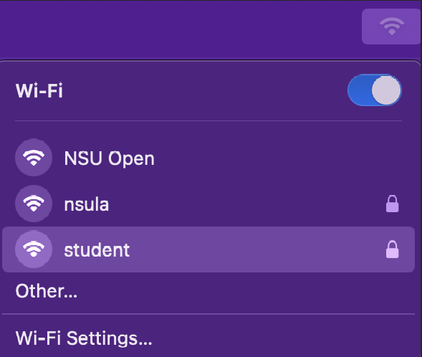

Step 2
From the list of available networks, tap student. Enter your myNSU username and password in the fields provided. Then tap OK to connect
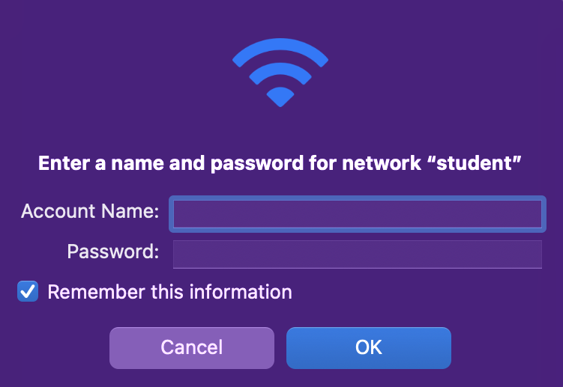

Step 3
Finally, tap Continue to accept the certificate.
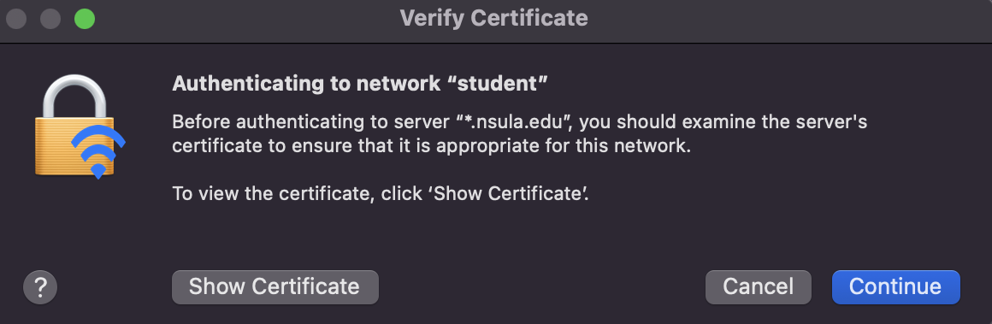

Once authentication is complete, your device will indicate that you are successfully connected to the student network.

